**MONISHA.DUSANAPUDI**

**Phase 9 Report: Reporting, Dashboards & Security Review**

**Non-Profit Donation & Volunteer Management**

**Objective:** The primary objective of Phase 9 was to translate the application's raw data into actionable business intelligence. This involved creating custom reports to answer key business questions and consolidating those reports into a single, high-level executive dashboard to provide an at-a-glance overview of the non-profit's performance.

**1. Report Types**

* To meet the project's reporting needs, both standard and custom report types were utilized. A new **Custom Report Type** named Events with Volunteer Sign-Ups was created.

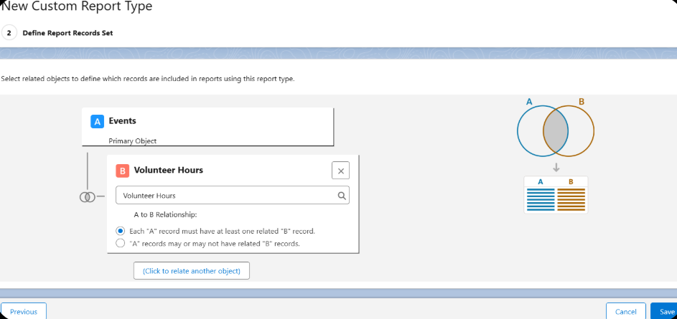

**2. Reports (Summary & Matrix)**

Two key reports were built to track the non-profit's core operations:

* **Report 1: Donations by Month**
  + **Type:** This is a **Summary Report**.
  + **Configuration:** It uses the standard Opportunities report type. The data is grouped by the Close Date field (specifically, by **Calendar Month**) and includes a summary formula to calculate the **Sum** of the Amount field for each month.
  + **Business Value:** This report provides a clear and immediate trend analysis of fundraising efforts, allowing leadership to see which months are strongest and to forecast future income.

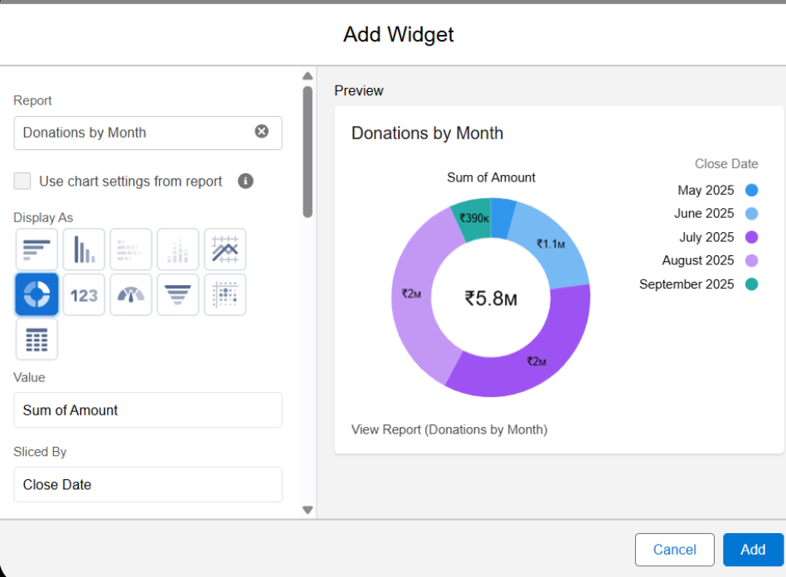

* **Report 2: Volunteer Sign-Ups by Event**
  + **Type:** This is also a **Summary Report**.
  + **Configuration:** It uses our new custom report type, Events with Volunteer Sign-Ups. The data is grouped by Event Name, and the report lists the full name of each volunteer associated with that event.
  + **Business Value:** This report is a crucial operational tool for the Volunteer Coordinator. It allows them to see at a glance how many people have registered for an upcoming event, helps in planning logistics, and provides historical data on which events are most popular with volunteers.

**3. Dashboards**

* A new dashboard named NGO Executive Dashboard was created to serve as the central hub for business intelligence.
* **Dashboard Components:** Two components were added to the dashboard, each visualizing one of the reports we created:
  1. A **Column Chart** was used to display the Donations by Month report, which is the best practice for visualizing trends over time.
  2. A **Donut Chart** was used for the Volunteer Sign-Ups by Event report, providing a clear visual breakdown of volunteer distribution across different events.

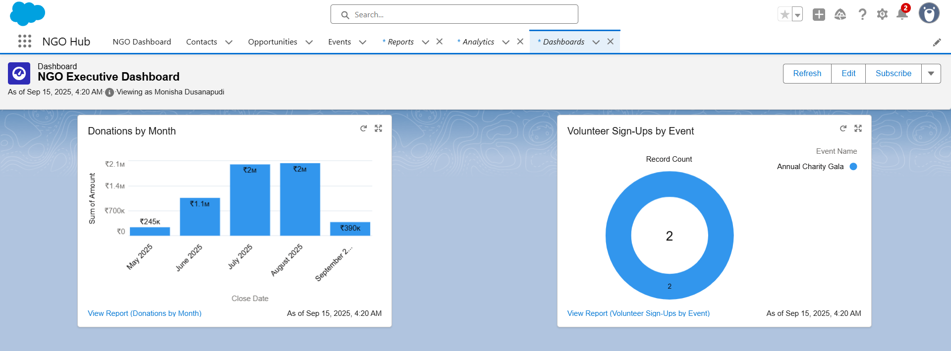

**4. Security Review (Sharing Settings, Field Level Security, Audit Trail)**

* A final review of the application's security posture was conducted.

**Overall Conclusion for Phase 9:** This phase is complete. The application is now equipped with powerful reporting and dashboard capabilities, turning its data into a strategic asset. The final security review confirms that the application is built on a solid and secure foundation. The project is now functionally complete.